**Exercise 1 - Dawson**

import java.awt.*;

public class DrawLoopFor

{

public static void main(String[] args)

{

DrawingPanel panel = new DrawingPanel(500, 250);

panel.setBackground(Color.CYAN);

Graphics g = panel.getGraphics();

int sizeX = 50;

int sizeY = 25;

for (int i = 0; i <= 10; i++)

{

int cornerX = i*50;

int cornerY = i*25;

g.setColor(Color.WHITE);

g.fillOval(cornerX + 5, cornerY + 5, sizeX-10, sizeY-10);

g.setColor(Color.BLACK);

g.drawRect(cornerX, cornerY, sizeX, sizeY);

g.drawString(Integer.toString(i-1), cornerX - 28, cornerY - 8);

}

}

}

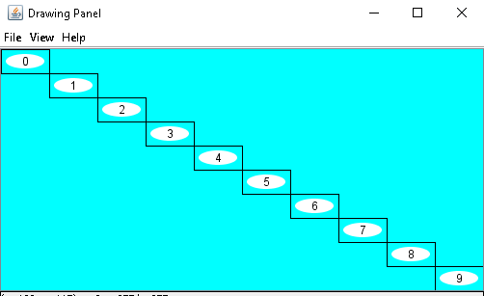

**Exercise 2 - Dawson**

import java.awt.*;

public class DrawLoopFor

{

public static void main(String[] args)

{

DrawingPanel panel = new DrawingPanel(500, 250);

panel.setBackground(Color.CYAN);

Graphics g = panel.getGraphics();

int sizeX = 50;

int sizeY = 25;

for (int i = 0; i <= 10; i++)

{

int cornerX = i*50;

int cornerY = i*25;

g.setColor(Color.WHITE);

g.fillOval(cornerX + 5, cornerY + 5, sizeX-10, sizeY-10);

g.setColor(Color.BLACK);

g.drawRect(cornerX, cornerY, sizeX, sizeY);

g.drawString(Integer.toString(i), cornerX - 28, cornerY - 8);

}

}

}

**Exercise 3 - Dawson**

import java.awt.*;

public class IfGridFor {

public static void main(String[] args) {

DrawingPanel panel = new DrawingPanel(400, 480);

panel.setBackground(Color.blue);

Graphics g = panel.getGraphics();

int sizeX = 40;

int sizeY = 40;

for (int x = 0; x < 10; x++) {

for (int y = 0; y < 12; y++) {

int cornerX = x*sizeX;

int cornerY = y*sizeY;

if ((x + y) % 2 == 0)

g.setColor(Color.green);

else

g.setColor(Color.yellow);

g.fillRect(cornerX+1, cornerY+1, sizeX-2, sizeY-2);

g.setColor(Color.black);

g.drawString("x=" + x, cornerX + 5, cornerY + 15); // text is

g.drawString("y=" + y, cornerX + 5, cornerY + 33); // offsets

}

}

}

}

**Exercise 4 - Dawson**

g.drawString("" + x + "*" + y, cornerX + 5, cornerY + 15); // text is

g.drawString("" + x * y, cornerX + 10, cornerY + 33); // offsets

**Exercise 5 - Dawson**

g.drawString("" + (x + 1) + "*" + (y + 1), cornerX + 5, cornerY + 15); // text is

g.drawString("" + (x + 1) * (y + 1), cornerX + 10, cornerY + 33); // offsets